
=

Training Resource Library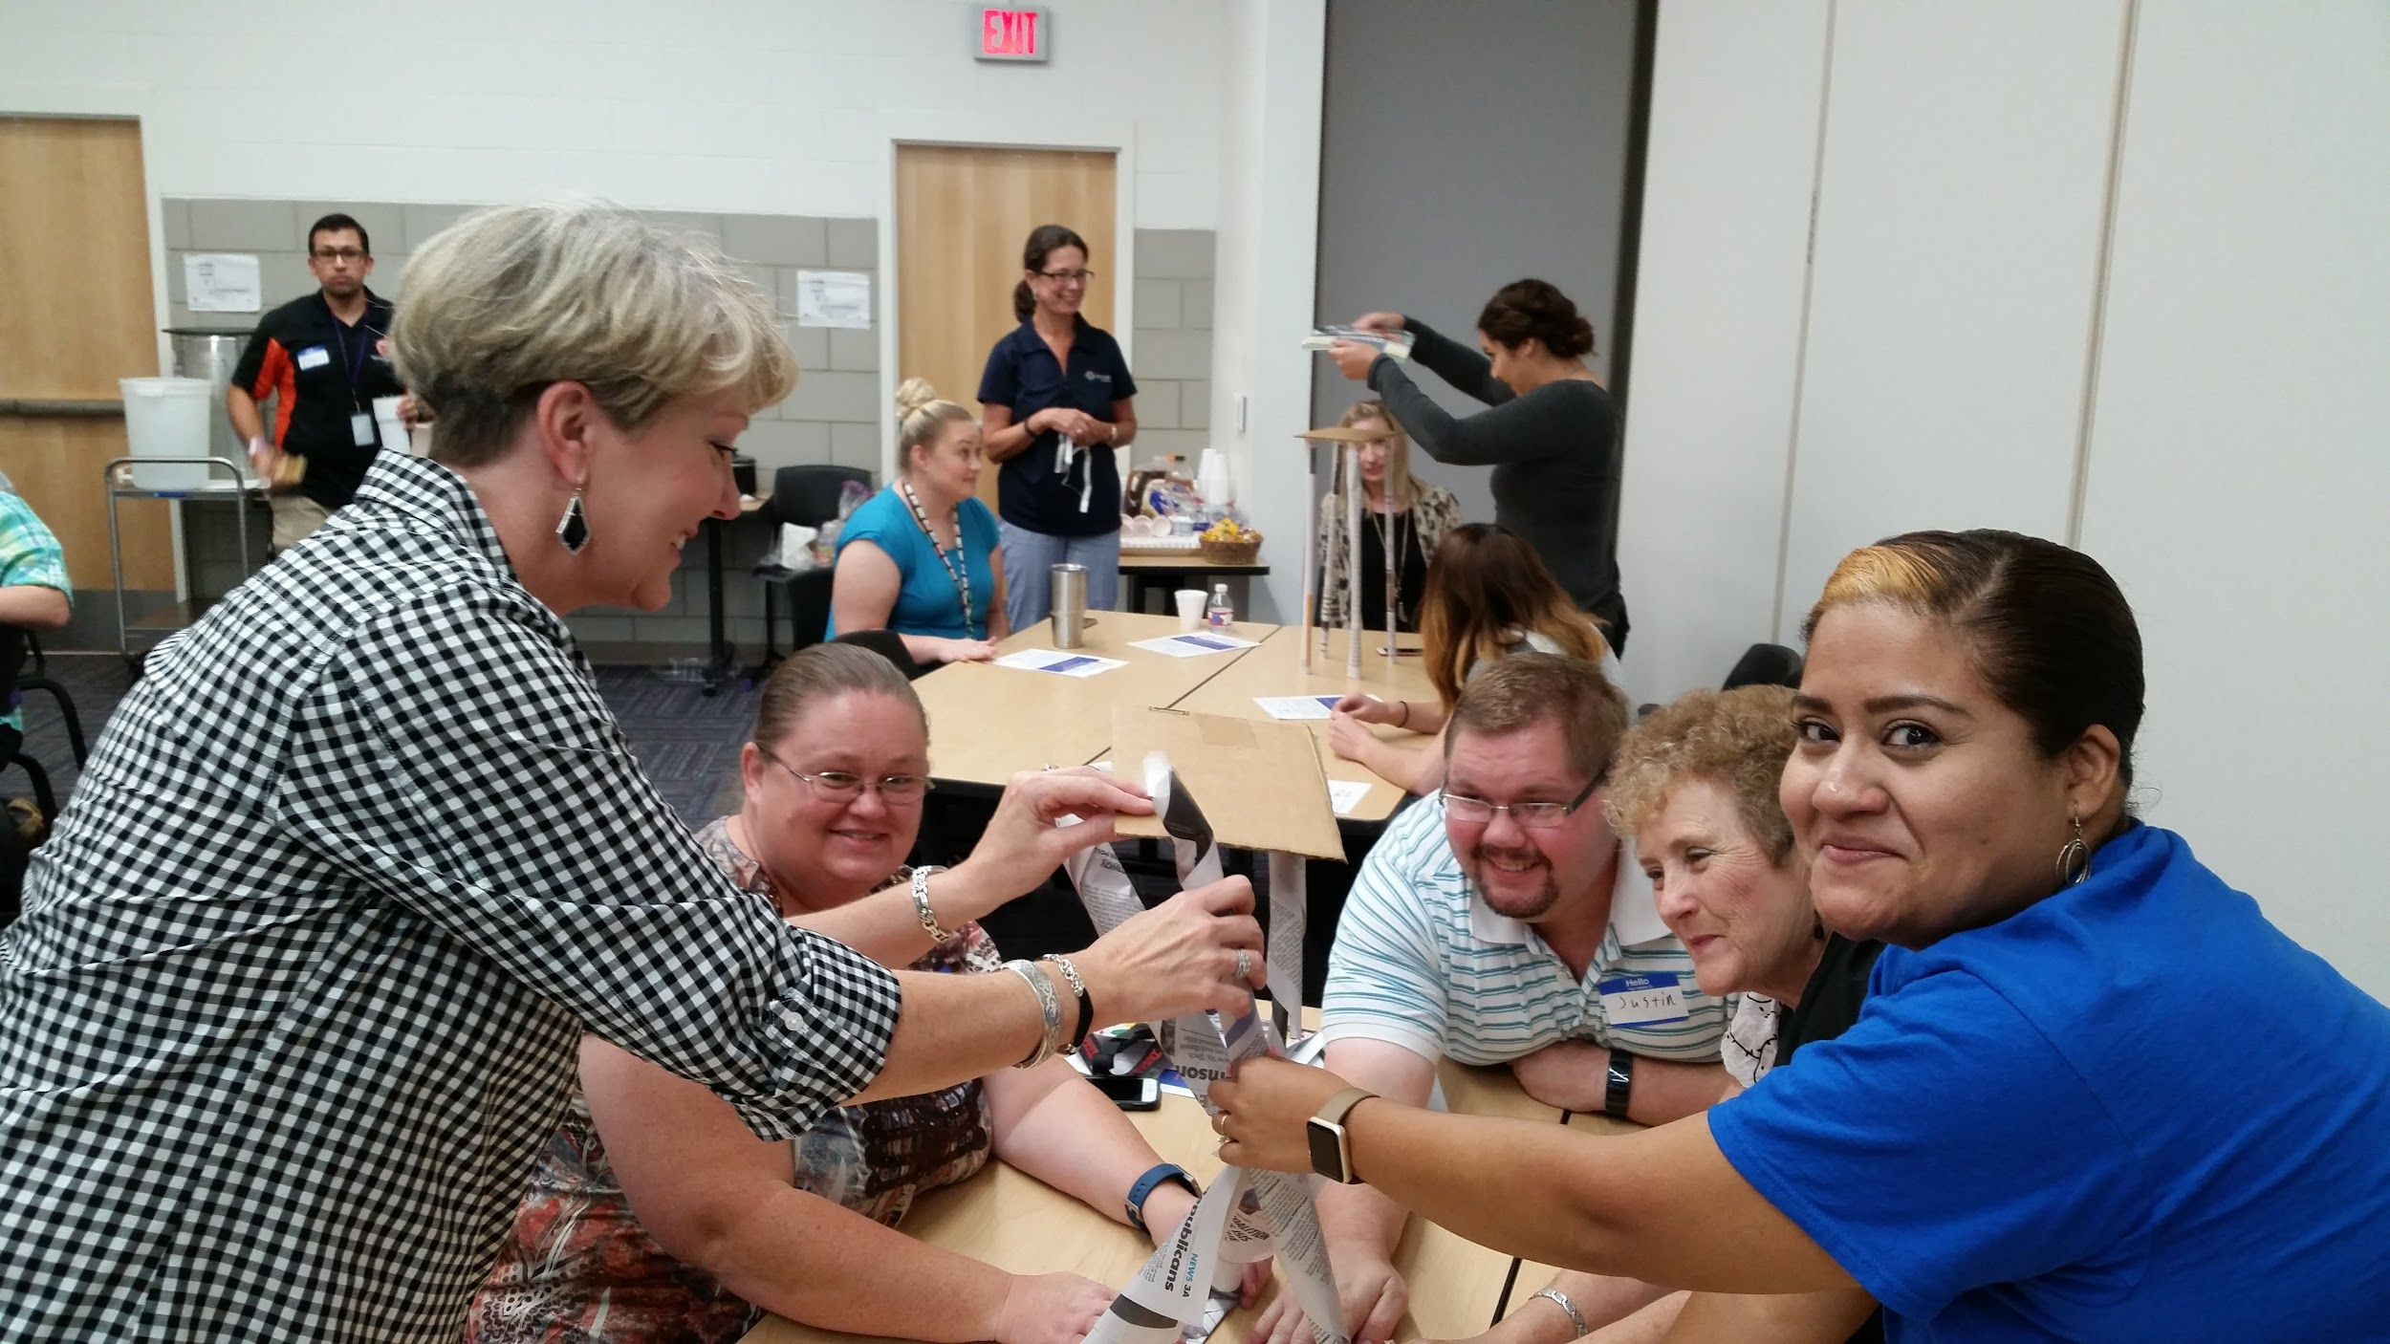

Welcome to JASON’s Training Resource Library! Here you will find resources and ideas for leading sessions in your own unique settings and sharing tips, ideas, and strategies with colleagues in your district or school(s). JASON’s mission is to inspire and educate students everywhere through real science and exploration. Thank you for being part of our mission to help make access to STEM equitable for all and develop the next generation of STEM-minded citizens and problem-solvers. We hope these resources will support the meaningful work you do in your districts, schools, and classrooms and create a culture of STEM within your communities.

* Please note that except where noted, the resources, programs, and training assets are the intellectual property of JASON Learning. It is expected that JASON trainers and coaches will use materials housed in this library solely for educational purposes to better the lives of teachers, students and community members within their districts, and will not be used commercially. Proper credit must be given at all times where appropriate. Materials containing the JASON branding should not be modified unless you have written approval. Trainers and Coaches may create their own slide decks and remix ideas as helpful in their unique settings. Please contact PD@jason.org if you need additional information or cannot access information.

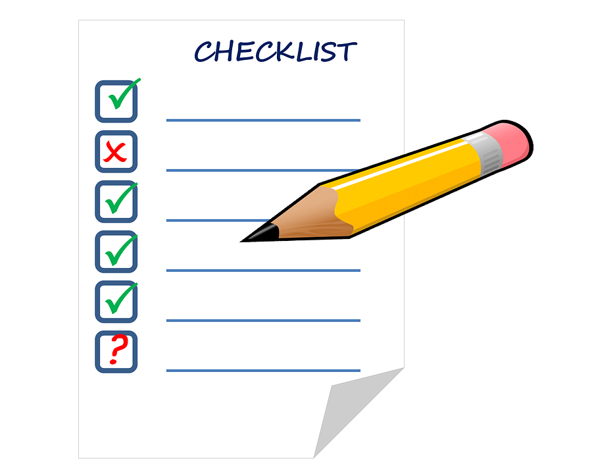 | Getting Started Checklist  Use the following “checklist” as a set of recommendations or guidelines that may help you get started as a JASON Coach, and as you begin to work with colleagues in your district. Areas of focus include:  - Outreach & Communication  - JASON Repertoire  - Training
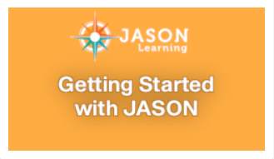 | Getting Started with JASON (also available inside gated site)  This collection includes resources to help educators and administrators get started with JASON in their classrooms, schools, and districts - from general descriptions of all of JASON’s collections and getting educators and students into the platform, to stories of implementation, community engagement strategies and more. This is also found on JASON’s main collections landing page inside the gated site.
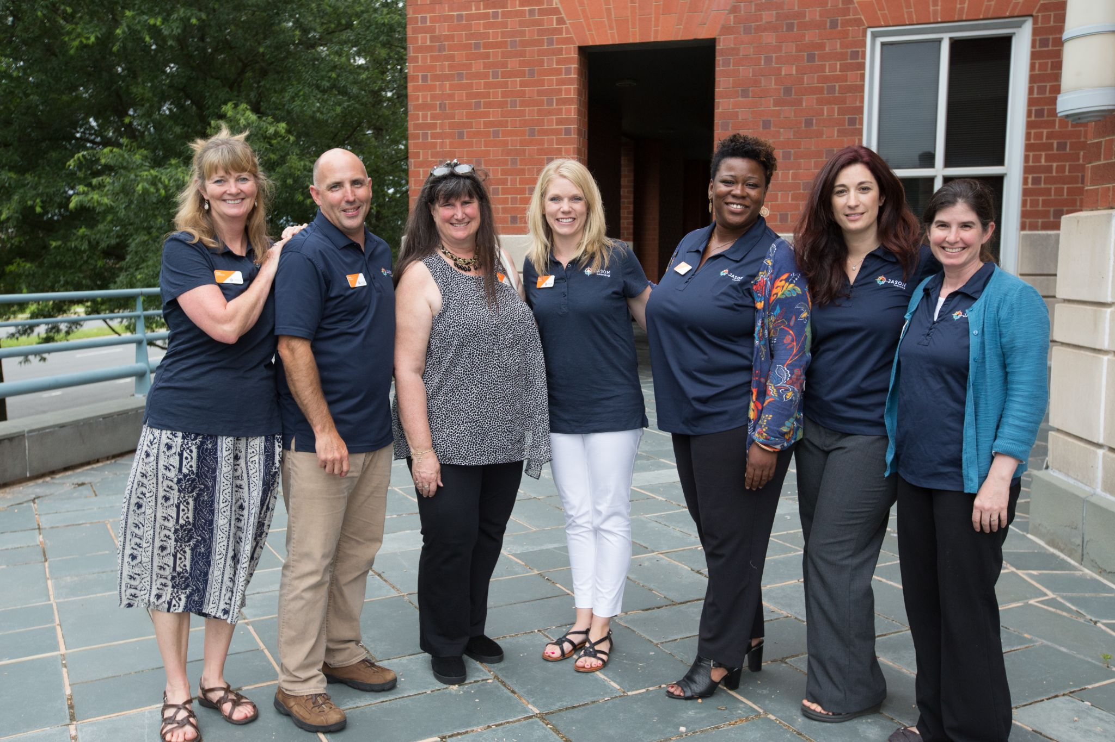 | Meet the Trainers  - Directory - National & Regional Trainers (work in progress!)  - Directory - Coaches (work in progress!)  - Trainer Expertise - Tap into team members’ strengths and expertise. Reach out to each other with questions, ideas, and helpful tips.
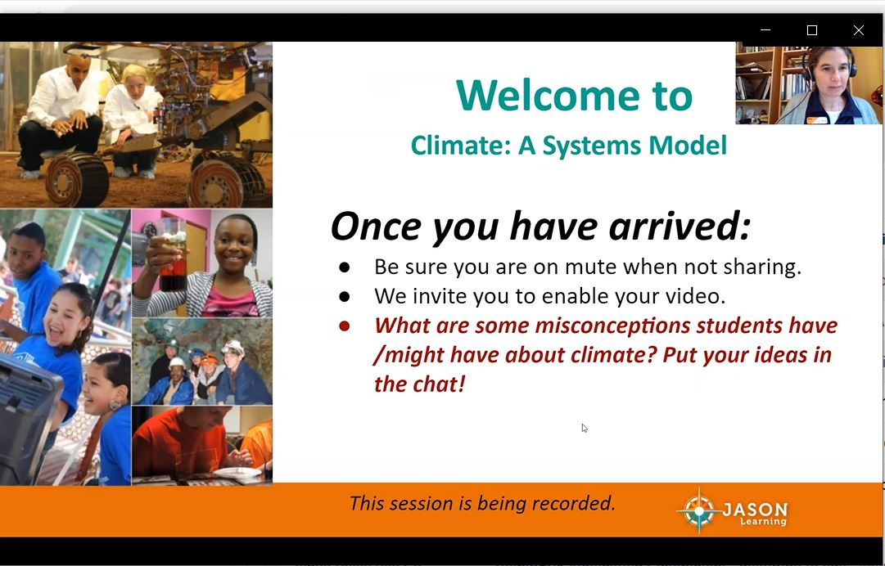 | Training Session Resources (this is a living document)  This collection includes resources that may be used to design and/or deliver PD experiences in your own setting(s) and general resources to help you and your colleagues become more familiar with JASON. Resources include video recordings, slide decks and outlines for selected virtual training sessions, and other activities, tools and strategies. Coaches can use the outlines and resources to train colleagues or use them as learning tools to design and customize their own professional learning.
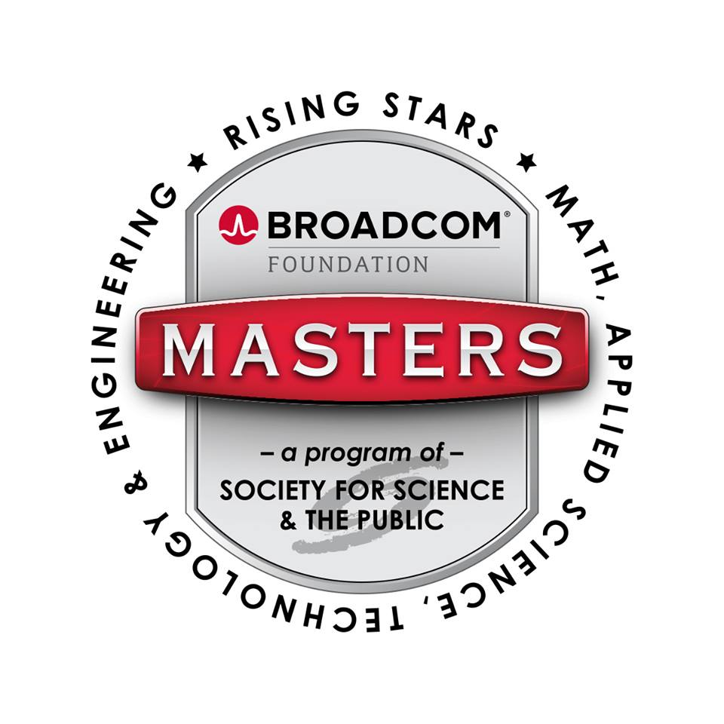 | Broadcom Masters  Broadcom Masters is a premier middle school STEM competition run annually by the Society for Science & the Public (SSP). Contracted by SSP, JASON Learning  has designed several STEM challenges that have been featured in this competition. Access these challenges and accompanying resources for district or classroom use. Note, all materials are the intellectual property of JASON Learning and may not be used for commercial purposes. Appropriate credit must be given to JASON Learning on all printed and digital materials when re-using or sharing.

Image credits:

warm-ups/team builders / Working together teamwork puzzle concept

Attribution-ShareAlike 2.0 Generic (CC BY-SA 2.0)

